BIOS 2
MEETING LOG 6
HARDWARE 38
SOFTWARE 61
FUNDRAISING 71
TEAM ORGANIZATION 73
PROMOTE VIDEO 77
TROUBLESHOOTING 79
OUTREACH 89

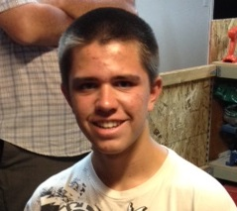
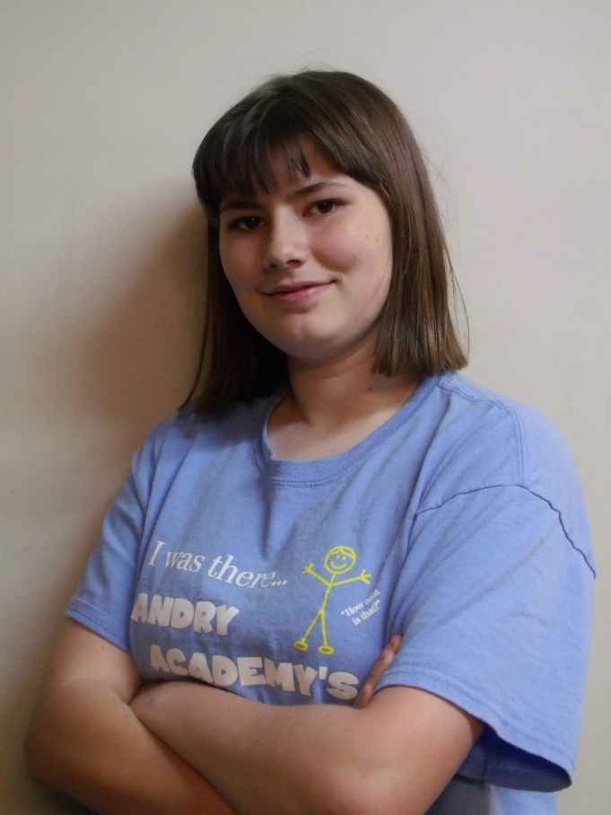
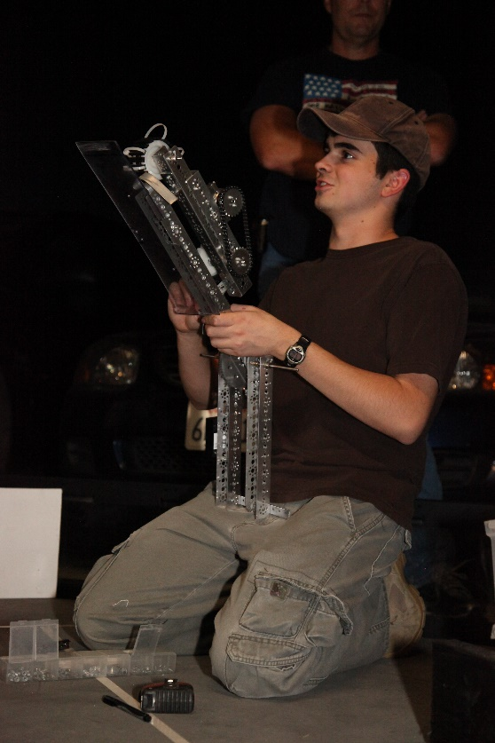

BIOS

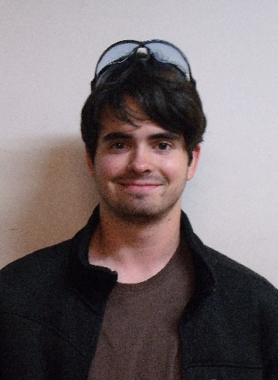
Jonathan Lokos 4th year on team
FAVORITE JOB ON TEAM: Team lead, hardware, 3D modeling, and driving.
HOBBIES: Robotics, airsoft, SCUBA diving, kayaking, and hiking.
INTERESTING FACTS: I am known in the robotics community as the “Beard of Knowledge”. I have been building and designing since I was three years old.

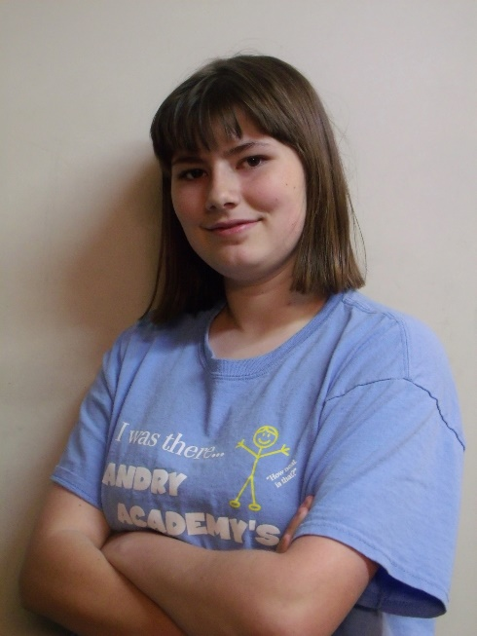
Kaitlin Cox 3rd year on team
FAVORITE JOB ON TEAM: Driving the robot and working in the notebook, as well as learning to write basic software
HOBBIES: Creative writing- particularly medieval fantasy stories and fanfiction- art, computer programming and game design, and roleplaying
INTERESTING FACTS: Over the course of the 2013/2014 school year I wrote the rough draft for a novel that is more than 110,000 words in length. I am currently editing the manuscript. I am also attempting to make a computer game using the Construct 2 platform. I am a keraunomaniac, which means I have an abnormal obsession with lightning. Not everything I say is meant to be taken literally.
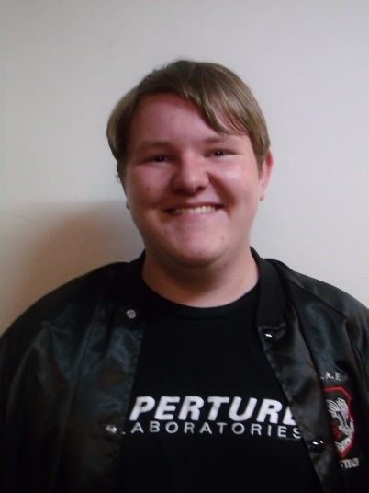
Eddie Pierce 3rd year on team
FAVORITE JOB ON TEAM: Hardware design, LabView programming
HOBBIES: Playing clarinet, PC gaming, novel writing, sketching, airsofting
INTERESTING FACTS: I have been known on the team as the designated target for all robots. For my first year on the team, I was called the Dementor, but that has since changed to Bones.
Noah Killian 2nd year on team
FAVORITE JOB ON TEAM: Software
HOBBIES: Programming, Cubing, League of Legends, Electronics
INTERESTING FACT: I’m too lazy to procrastinate so I’ll procrastinate later.

Holly Creech 1st year on team
FAVORITE JOB ON TEAM: Working on the notebook, and learning hardware.
HOBBIES: Playing the piano, teaching the piano, and writing.
INTERESTING FACTS: I love owls, chocolate, listening to music, and spending time with friends.
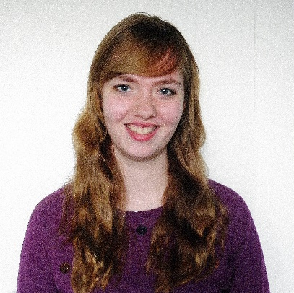

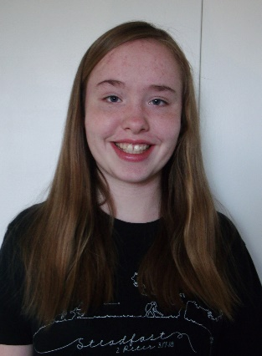
Hanna Creech 1st year on team
FAVORITE JOB ON TEAM: Hardware
HOBBIES: Photography, Baking, Piano (music), Swimming, And Drawing
INTERESTING FACTS: I enjoy my pets especially my dog and guinea pig. I’ve been doing piano for over 6 years and the flute for 1. My favorite color is blue.

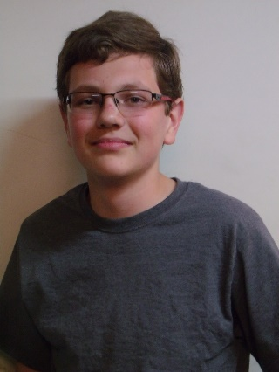
Sergei Cox 1st year on team
FAVORITE JOB ON TEAM: Hardware
HOBBIES: Softball, building things, reading.
INTERESTING FACTS: People call me different things and say my name wrong. I’m the weirdest person I know.

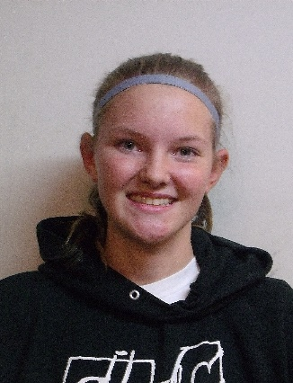
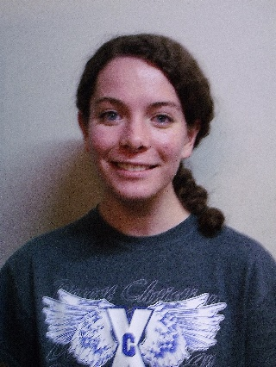
Becky Pierce 1st year on team
FAVORITE JOB ON TEAM: Software
HOBBIES: Playing volleyball and softball, running cross country and track, baking, piano
INTERESTING FACTS: I’ve been homeschooled my whole life. I helped start an FLL team in 2011. I used to be on a bowling team. I hate looking for nonexistent screws. I love the Dodgers.

Anna Leland 1st year on team
FAVORITE JOB ON TEAM: Hardware
HOBBIES: Running Hurdles, Reading, SCUBA Diving, Script Writing
INTERESTING FACTS: I manage my school’s Cross Country Team and I’ve directed my school’s play for the past three years.

MEETING LOG

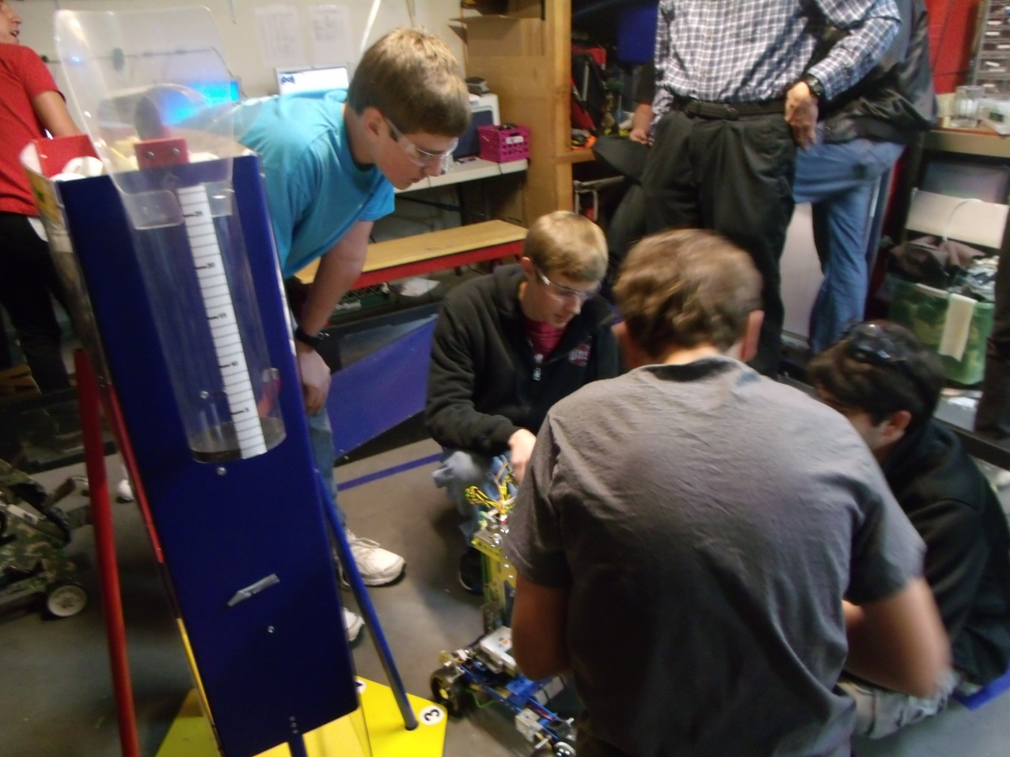
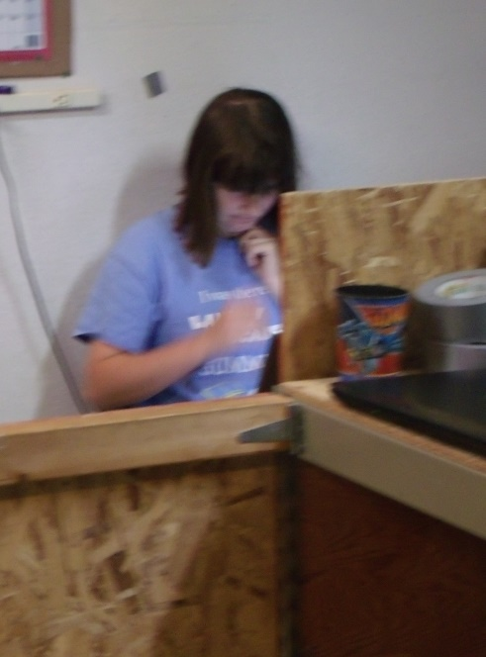
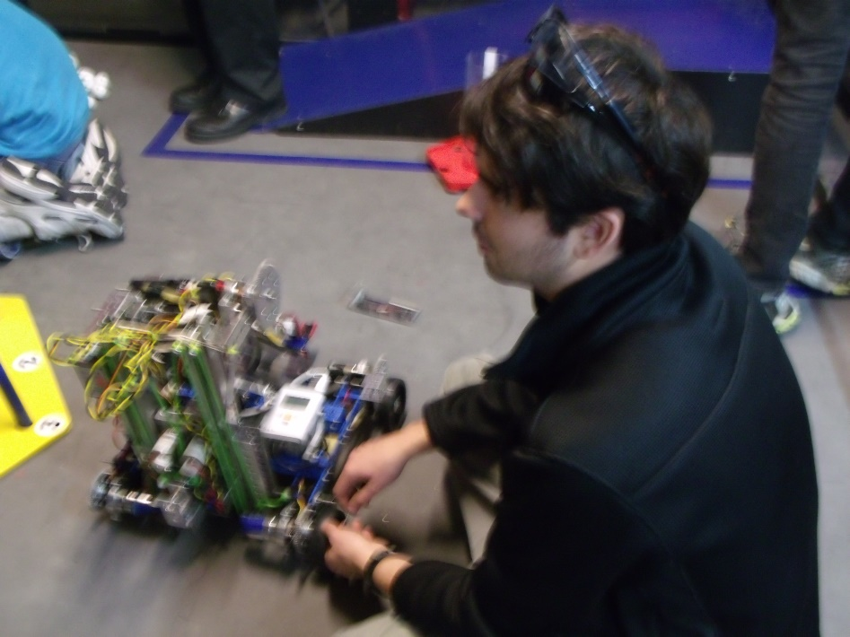
STAR DATE 9/8/2014
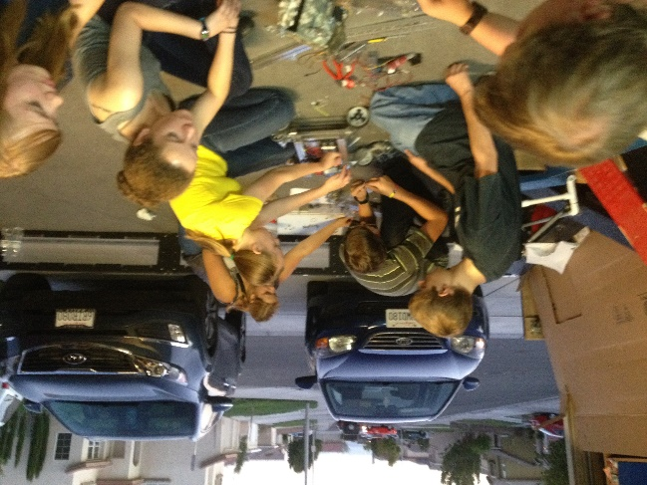
HARDWARE
HMC
Tonight we all sat down and brainstormed. We came up with a bunch of ideas so that we could begin prototyping. One that we spent time on was a tube like device, “The da Vinci,” that could be used to pull balls into the robot, and hold them like the field tubes. We cut out pieces of cardboard and duct-taped them together to form the basics of “The Da Vinci” prototype.
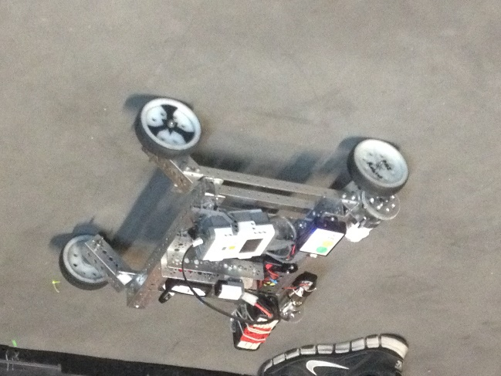
SOFTWARE
NK
Our goals for tonight were to give some of the freshmen an intro to programming in RobotC which is the language our team uses.

Tonight we explained the basics of RobotC to the freshmen interested in learning it. We explained pragmas, includes, and basic motor controls.

STAR DATE 9/11/2014
HARDWARE
JL
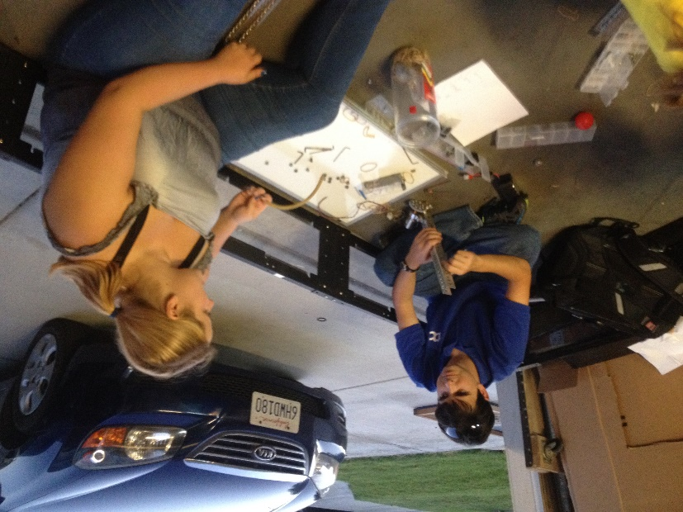
Our goals for tonight were to rebuild both of our 2013-2014 chassis so we could mount prototypes and test them. We also wanted to brainstorm further ideas for ground intake systems.

Tonight we accomplished rebuilding and wiring both robots. We succeeded at mounting some prototypes on one of the robots and the freshmen learned how to program the other. We familiarized some of the freshmen with parts of the TETRIX kit. We also brainstormed an inverted funnel for scoring balls in the tubes.

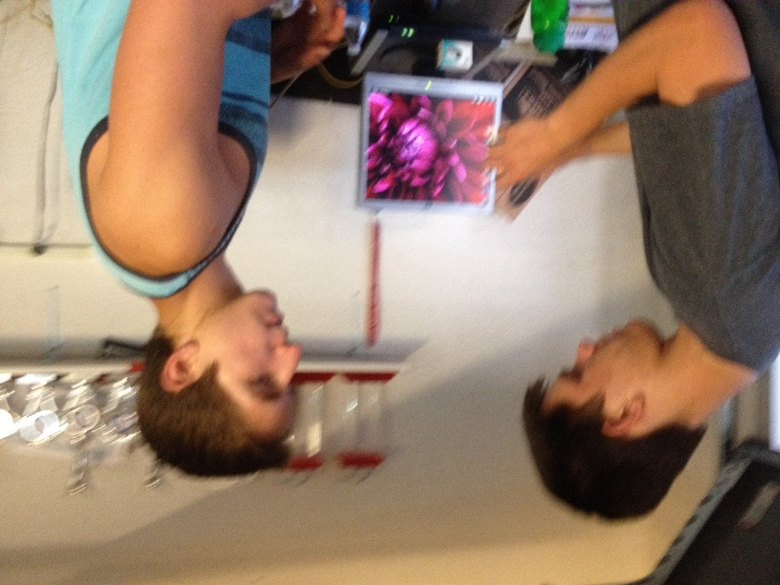
SOFTWARE
JM
We further instructed freshmen on programming, teaching them about pragmas, how to control the motors, and how to create autonomies. We also explained basic C syntax.

NOTEBOOK
KC
Tonight we set up a syncing application to allow us to sync important files such as the Engineering Notebook, code files, and pictures between computers. We also set up a new, more detailed format for the meeting log.

STAR DATE 9/15/2014
HARDWARE
MK
Our goals for this meeting were to further our designs for collecting the balls. We also wanted to brain storm and come up with new designs for lifting and scoring the balls.
We improved a conveyer belt-like design for collecting the balls. It has cardboard paddles on it that are slightly u-shaped and are designed to scoop up the balls and drop them into the bucket. This bucket is attached to a drawer slider which is used to lift it.

SOFTWARE
NK
We continued to work with the freshmen and their coding skills. As they learn more, they will be in charge of the very basic autonomies and tele-ops while those of us that are more experienced will work with the more advanced concepts.

STAR DATE 9/18/2014
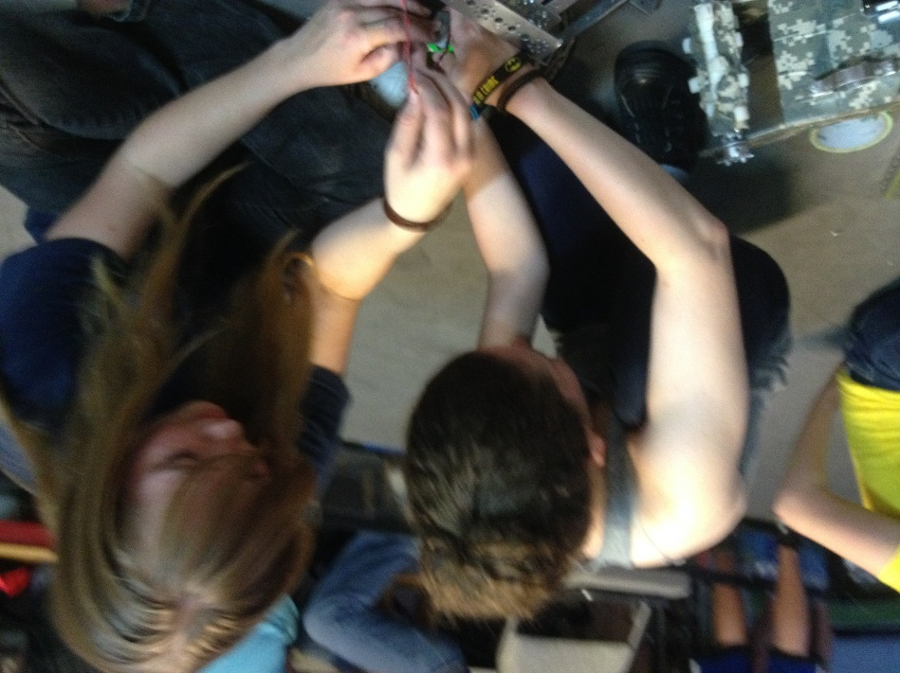
HARDWARE
SC
We wanted to finish our prototypes, make more prototypes, and build our game field.
The main prototype that we have been working on is a conveyor belt that picks up balls and carries it up into a bucket. The bucket is mounted on a linear slide that carries it with the balls to the height of rolling goals. We also made a smaller tube that is around the conveyor belt to help both ball sizes go up through it into a bucket and extended the width of the flaps of card board so that the conveyor belt could pick up both sizes of balls, and made a bucket to hold the balls to score them into the goals. In addition to this, we prototyped some ideas for grabbing the rolling goals.

SOFTWARE
JM

We discussed finding distance from acceleration and finding distance from IR sensor values. We were theorizing ways to use double integration so that we would be able to ascertain accurate distances from the accelerometer and are now trying to find equations that will allow us to do so. Unfortunately, double integration can greatly multiply error so we need to find a way to make measurements as accurate as possible. We are also theorizing ways we can find distance with IR finding the angles we are from the IR emitter and then using trigonometry to find our relative position.

STAR DATE 9/22/2014
HARDWARE
CS
Tonight we finished off the field build by assembling the last parts of the ramp, and adding the tapped lines to the floor to mark off the specified zones/goals.
Our first prototype was a small “L” shaped piece designed with a bendable edge that would fit on the back of the robot. The robot would drive backwards bending the edge to snap onto the rolling goals, and then proceed to drive to the scoring zone. This piece could also be modified with a servo to allow it to be raised/lowered onto the rolling goal lip.
Our next prototype we fitted onto a square-bot to get a better look at it. It consisted of a conveyor belt fitted to raise the whiffle balls into a holding container. Once the container was filled, an arm would proceed to raise the container, and dump the balls into whatever rolling goal was desired.
Our third prototype for the night still needs some work. It is designed to be a tube that will pull in the whiffle balls using foam prongs attached to motors. A sensor will count the amount pulled in, and will stop the mechanism at the desired amount. After this, the robot will be driven up to a rolling goal, and the balls will be deposited out of a “U” shaped piece at the top of the container. In order for this design to work, we still need NASA to cut out certain sections of the tube, and supply additional parts.
Our final design for the night consisted of an arm, holding area, and an elevator. We designed an arm to catch balls, and put them into a sloped holding container. The balls would all roll to the corner where an oval shaped conveyor would scoop the balls out, flip over, and dump them into a desired container on their “O” shaped path.
SOFTWARE
NK
We have decided on some of our autonomous goals and general software goals this season. One major objective we are pursuing is the control award. We are seeking out unique ways to use sensors and intuitive, dynamic methods for our autonomies. Our main idea for this is finding displacement from acceleration.

STAR DATE 9/25/2014
HARDWARE
CPB
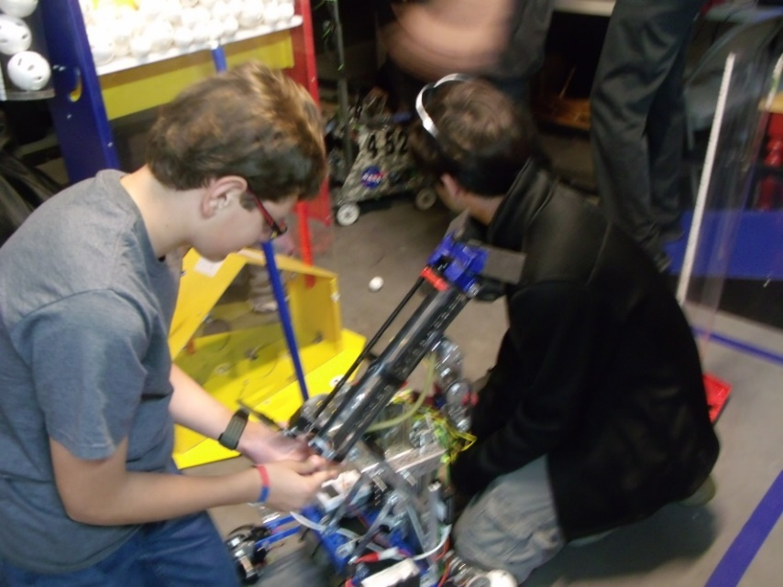
We built some prototypes tonight. One of the prototypes we built was a little box hand that helps us pick up balls. It’s workable and easy to operate. Another prototype that we did was, attach a second linear slide for extra height. We finished wiring the bot and finished building the shield around the conveyor belt, to contain the balls when we pick them up. We also created a funnel to help guide the balls into conveyor belt.
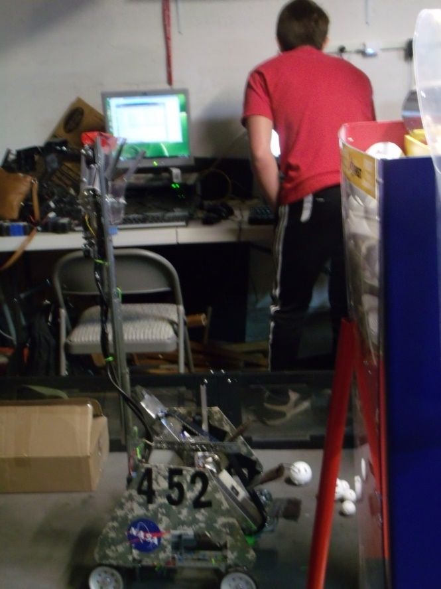
SOFTWARE
NK
We are looking at the various ways to perform a double integration on our accelerometer values to determine distance travelled while minimizing error. Some of the methods we have encountered are Simpson’s Rule, Trapezoidal integration, rectangular integration, and Boole’s rule. Trapezoidal appears to be the one we will use.

STAR DATE 9/29/2014
HARDWARE
HRC
Tonight we worked on prototypes. One of the prototypes we worked on is a bucket. The bucket is lifted by a linear slide. The purpose of the bucket is for the balls to drop into it and for it then (using the linear slide) to take the balls up and drop them into the scoring goals. The bucket can also tip for more accurate and more consistent scoring. Another prototype we worked on is a way to pick up balls. It uses zip ties and no slip grip in a rectangular box. We also discovered some things we could work more on to improve.
SOFTWARE
NK
We are still looking at the various ways to perform a double integration on our accelerometer values to determine distance travelled while minimizing error. Some of the methods we have encountered are Simpson’s Rule, Trapezoidal integration, rectangular integration, and Boole’s rule. Trapezoidal appears to be the one we will use.

STAR DATE 10/2/2014
HARDWARE
HRC
We started to build our robot tonight and apply some of the ideas we had come up with. The main thing we did tonight though, was wire the robot. We also worked on some new prototypes. An example of what we prototyped tonight was a way to clasp to the bottom of the rolling goals. Another example is a way to intake balls.
SOFTWARE
NK
We’ve decided that our main focus for the autonomous period will be to score our two balls and knock down the kickstand. We would like to use the center goal for one of our balls if the robot is capable.

STAR DATE 10/6/2014
HARDWARE
EP
Tonight, Phi Alpha and Omega opened in prayer together, then each team discussed what they would work to accomplish during the meeting. After settling what each of the team members was working on, the teams split ways to work towards their individual goals. The meeting’s work got started with an in-depth stress test of the 3D printed plastic nacelles for Khan’s chassis. A small group constructed a simple mount for a small video camera one team member owns. After the mount was completed, it was mounted to the robot in a position such that the camera could watch the springing motions of the nacelle. After several short drops off the side of the ramp, one of the front nacelles broke in two. Through detailed examination, we observed that the plastic sheared from front to back, a place in which we were warned that shearing could occur if put under stress. Fortunately, we had a spare on hand and the nacelle was quickly replaced. After thinking of a fix to this problem, we accessed the computer model for the part and increased the thickness of the walls by three. Then the new part model was sent to our 3D printer contact for construction. Soon after, we discovered the other front nacelle was developing a crack as well. The chassis was set to the side until we could get the better replacement parts and the group that was working on the chassis turned to other projects.
During the stress testing, a separate group of Phi Omega members was working another prototype for scoring. This prototype is a large bucket with two brushes on the top for intaking the balls. Then it would dump the balls out the back of the bucket. The brushes were recycled from a previous scoring system from the previous year’s challenge.
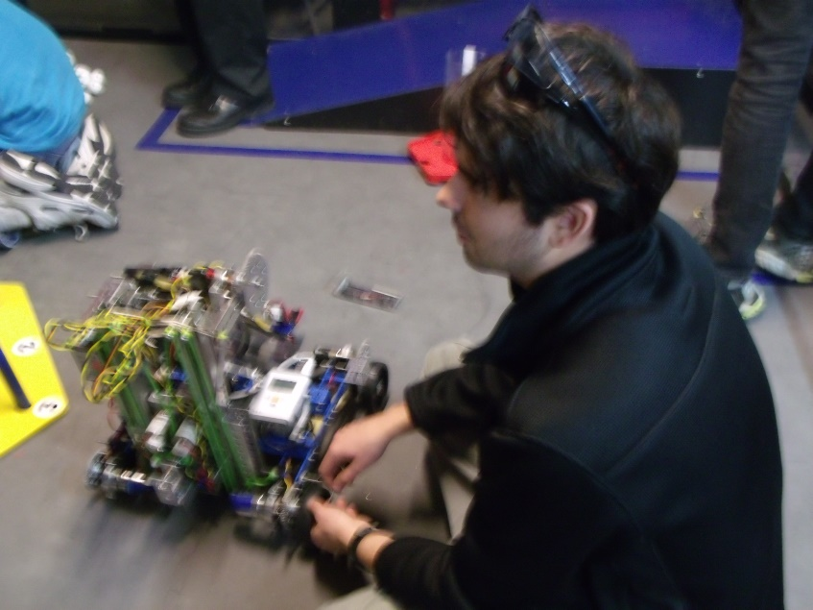
One set of team members that moved from the chassis of the robot began reworking another of the few prototypes we have. The “Da Vinci” had a major redesign and the paddle-like intake mechanism was disassembled to later be replaced with a belt system. The rest of the team members that were previously working on the chassis helped Phi Alpha with their robot.
Shortly before the meeting ended, we stopped building to clean up the mess we had made. Then we had a short debrief detailing what each group had accomplished. Finally, the meeting was ended with prayer.

SOFTWARE
NK
We decided to go over practical ways to accomplish the tasks that we have laid out as goals for our autonomous period. These include IR trigonometric functions for positioning, dynamic control via a map of the field stored in the robot’s memory, and pre-coded static instructions.

STAR DATE 10/9/2014
HARDWARE
KC
Today we repaired the wheel system with new 3d-printed parts after we discovered that the original models were prone to cracking when subjected to stress. We also worked on the intake tube, and began work on the arm that will lift it. We have been working on a three-stage arm that remains parallel to the ground as it raises that, when completed, should be able to reach the highest goals.

SOFTWARE
NK
Tonight, we decided to continue in teaching some of the newer members about the software we use so that they can be ready to help with the coding of the robot. We are still mostly covering the basics of the language with them and we have started some of the built-in RobotC functions such as motor control.

STAR DATE 10/13/2014
HARDWARE
HMC
Tonight our team mounted the arm structures onto our robot, and worked on our ball intake brush system. Although they both still need some work, we have made progress. Some of the seniors worked with our team to locate parts from past years that we could recycle and work into this year’s robot. We continued perfecting the video, and continued to work on setting up this year’s notebook. At the end of the night we were all able to view the stage of the video we were at, as a group.

SOFTWARE
NK
We continued in attempting to gain displacement data from acceleration. Being a double integration, error tends to propagate quickly and so we are trying to find ways to optimize the code and minimize this. One big factor is sample rate and so we are trying to take as many samples per second as we can.

STAR DATE 10/16/2014
HARDWARE
SC
We made some chain and cut metal for the three joint arm. We also drilled the holes that the chain gear runs on and geared it to power the arm. Then when we tried to assemble it. We found that the length between the gears that the chain runs on was either too long or too short, so we marked where the gear would need to go by holding the chain on the gear and marking it. Then we drilled the holes and tried to mirror that on the other pieces of metal.

SOFTWARE
NK
We looked into what it would take to determine the IR’s position from the top of the ramp. We found that regardless of the IR’s orientation, you could not get 3 unique values from the positions of the beacon. We decided to explore other options for performing altering-position related tasks.

STAR DATE 10/20/2014
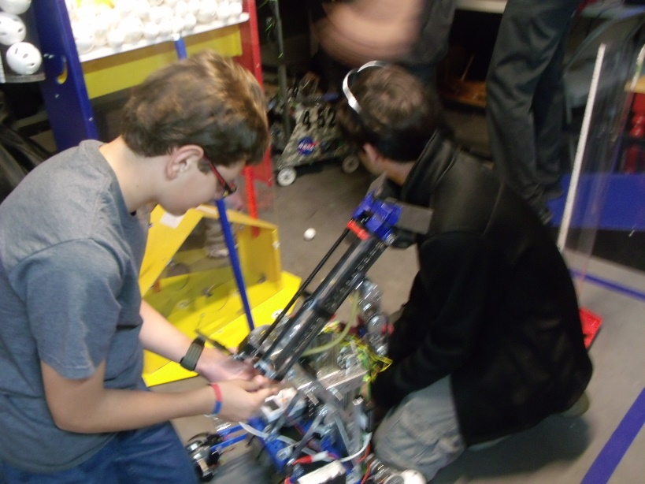
HARDWARE
HMC
We continued working on the three-joint arm tonight. We checked the chain we made for the arm last week. We repeatedly tested it and worked to improve it when flaws in the design came up. We were able to work parts from last year into the bot when needed. We also progressed in our work on the award video.
SOFTWARE
NK
Tonight we looked at our previous tele-ops and decided to see what room for improvement there was. One issue we found with the previous program was that in our use of stick-shaping, we were limiting maximum motor output to about 59%. We fixed this by finding a new curve for our stick shaping. We succeeded in finding one that the drivers liked.

STAR DATE 10/23/2014
HARDWARE
A.L.
We continued to work on the three-joint arm and attempt to the fix the mechanical errors we ran into. We managed to attach it to the robot, however several usage errors still exist. Fitting the gears needed to run the arm is proving the biggest issue. The chassis doesn’t have enough space between the wheels to fit a straightforward gear set-up. We continued planning for the upcoming yard sale and decided when items should be dropped off for the sale.
SOFTWARE
NK
One of the things we have always done is separate tasks in our tele-ops. This year we decided would be no different. We have one task for driving, another for button control and a last one for any random processing the robot needs to perform.

STAR DATE 10/27/2014
HARDWARE
HRC
This week we spent a lot of time preparing for our yard sale. Some of us made signs to advertise it. We scheduled each person’s shift for the yard sale so that there wouldn’t be shifts without enough workers and vice versa. The team worked to complete the final hardware implementation. Also, we developed some autonomy programs.

SOFTWARE
NK
One thing we found when talking to our drivers about the tele-op is that some of them preferred tank drive while some still preferred the traditional single -stick drive that we have been using. We decided to appeal to both groups by making the Select button a toggle between tank drive and single-stick drive.

STAR DATE 10/30/2014
HARDWARE
SMC
Our goal was to put motors on both sides of the arm. With one arm we didn’t have enough power to lift the arm up. We worked on the three joint arm and were trying to figure out how to make the robot fit into dimensions. One of the motors stuck out of the dimensions and we couldn’t flip it around. We needed to gear it so that we would get enough torch so that we don’t burn out the motors. We found that our idea was too complicated and decided to work on a new idea.

SOFTWARE
NK
Tonight we worked some more at our distance from acceleration software. We are continually getting more accurate. We are still experimenting with various integration methods from trapezoidal integration to the classic physics equations which were founded using the integral of acceleration to find velocity and the integral of velocity to find displacement. These can possibly work because even though it is not quite constant, we assume it is constant between samples and use this for the equation input.

STAR DATE 11/3/2014
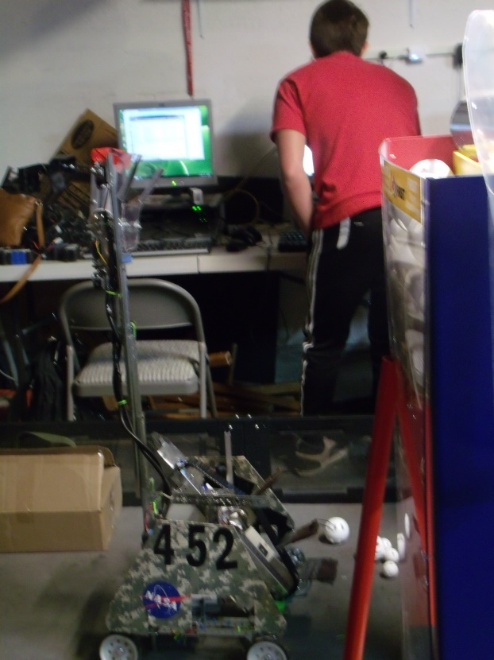
HARDWARE
BP
We changed the three joint arm to be sliders. The reason was because it was a simpler design and we could have the bot ready in for competition. We installed the winch to the back of the robot to make the slider arms go up. We also made a few tweaks to the ball intake to make it so both balls can easily be fed into the tube. After that, we wired the bot and checked all the wiring to make sure it was clean and acceptable.
SOFTWARE
NK
Tonight we worked some more with the newer members showing an interest in code. We’re still prepping them to be able to write their own basic autonomies and tele-ops as well as giving them the knowledge to be able to troubleshoot when things go wrong.

STAR DATE 11/6/2014
HARDWARE
HRC
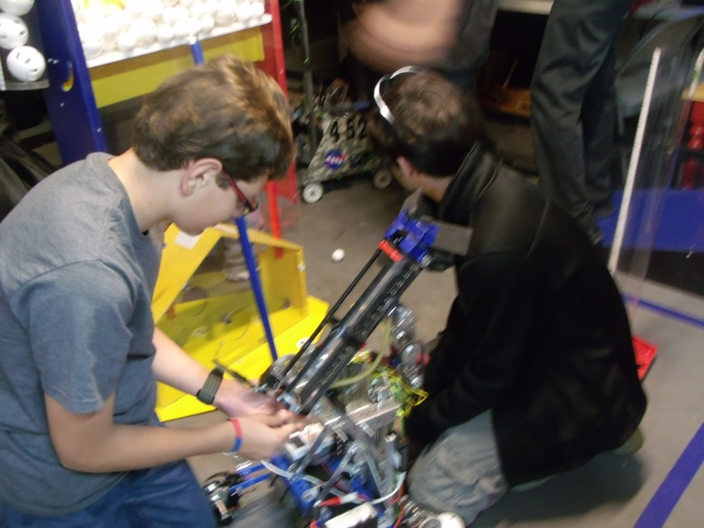
On Monday we put a servo on the tube that opens and closes to let the balls out. Later that evening we re-wired most of the robot again so that it can work and run more smoothly. Also, we attempted wiring the arm, making sure it could reach to the top of the linear slides. We put on a Samantha, mounted an NXT, and placed the Battery on the robot. We tweaked around to improve the overall design.
SOFTWARE
Tonight we again looked at possibilities for earning the control award. Our distance from acceleration program is close, but not accurate enough to be used in its current state. Our software to use the encoders has a relatively high error margin but is still a bit more accurate than our current distance from acceleration program. We are now trying to find another way to give us a shot at the control award. We are looking at ways to effectively zone in on the IR.

STAR DATE 11/10/2014
HARDWARE
SC
Our goals were to finish wiring our robot, do drivers practice and to put a servo on our tube that flips and scores the balls. We needed a long wire to run up our linear slide but we didn’t have the wire we needed. So we put a couple braces to stabilize the linear slide and we wired our winch that lifted the slide. We thought that it would be good to have another robot so that some of the new people could practice traveling around and playing defense so we built another square robot. The square robot is just a simple chassis that is run by two motors and some chain. The last thing we did was to test the individual units and make tweaks to it.

SOFTWARE
NK
Since we could not get 3 unique values from any position on the ramp, we had to look at a different way to determine the IR’s position quickly. What we did find as that at the top and bottom of the ramp, there was a solo value and also two that were the same. This does not give you the IR position. However, we found that the top duplicates were offset from the bottoms by one and so we were able to use this information and take the IR reading twice, allowing us to narrow down the IR to a single position by the second sweep.

STAR DATE 11/13/2014
HARDWARE
HMC
Tonight we got the wire we needed to finish the wiring on the robot. We also finished up our linear slides. We continued finishing our bug-bot so that we could have driver practice with two robots. We also needed the bug-bot to be able to program some simple autonomies before competition. We worked on added some final pictures to the award video, and also worked on completing the credits.
SOFTWARE
NK
Now that we can find IR, we need a way to navigate to it. We decided on trigonometry. One way to create a triangle is to have two IR sensors as one vertex each with the beacon being the necessary third. Our other idea is to record the angle between the sensor and the beacon from one position, drive a set distance forward and then find this angle again thus creating the second vertex from the same sensor. We can use this triangle to get any information we want about our position relative to the IR beacon.

STAR DATE 11/17/2014
HARDWARE
AL
We worked on rebuilding the belt on the intake system. We took a strip of plastic netting and covered it in no-slip grip. We used zip-ties to attach the netting to the no-slip grip and cut off the extended tails of the zip-ties. This made a belt with tiny zip-tie plastic nodules that would be able to help pull up the whiffle balls. We then attached the belt to the actual intake system. We tested it out and found that the whiffle balls had a tendency of slipping down and out of the intake system once collected.
SOFTWARE
NK
Today we decided to code some of the specifics for the robot into the tele-op so that we could test out the robot as a whole as it was ready. We added support for the buttons and triggers and individual components of the robot.

STAR DATE 11/20/2014
HARDWARE
BP
We continued working on our intake system and have nearly finished it. The balls now do not slip out once collected. We started making some ideas about changing our conveyor belt. We made some prototypes on what it would look like and decided on a final prototype. Next week is when we will start on changing it.
SOFTWARE
NK
Tonight we decided that, in spirit of the control award, we need expandability for more sensors than the three that the NXT allows. Our options were a multiplexor and a SuperPro prototype board. We chose the prototype board due to the freedom it allows for. We will probably use it with a 10-dof imu using I2C protocol.

STAR DATE 11/24/2014
HARDWARE
HRC
Tonight, we changed our conveyer belt. Our new conveyer belt has chain with nails instead of pins. There are two nails every four inches that are secured on by electrical tape. On the nails we put foam paddles. The paddles are a T shape.

SOFTWARE
NK
After more research, we found that the prototype board does not natively support acting as a master for I2C communication. We have decided to take on the challenge of coding a soft-I2C master. One issue we are concerned with regarding this method is that I2C can take time and if we have to control the prototype board using I2C and then a second I2C layer to retrieve data from the sensor, it may take too much time and harm our sampling rate for finding distance from acceleration.

STAR DATE 11/27/2014
HARDWARE
BP
We continued to change the conveyor belt. We tested to see if the T shaped paddles worked to keep both the small and big balls secure. We tightened the robot to see if any problems were because of loose screws.
SOFTWARE
NK
We now have a prototype board and a GY-80 imu. We have begun coding the I2C master and are testing as we go. We are able to fully control every port on the prototype board so that is a good start. We have not had a successful read as of yet but we are still trying.

STAR DATE 12/1/2014
HARDWARE
HRC
Tonight we worked on rewiring the robot in hope that it would fix some of our problems. We also re-did the paddles, we shortened them and hoped that that would help the conveyer belt run more smoothly. We changed out the chain gears to a smaller size on the wheels.
SOFTWARE
NK
We are having a lot of trouble trying to get the values from the sensor using this double I2C communication. We are going to temporarily put this off as we are getting closer to competition. We decided that we should create a back-up option for moving accurate distances in our autonomous period. We decided on using standard encoders. We are looking at our team’s traditional move function and attempting to increase its accuracy with a better calibration.

STAR DATE 12/4/2014
HARDWARE
AL
We switched out some of the wheel gears on the robot. We also replaced a few problematic axles with un-damaged ones. We helped smooth out the intake system by making sure the new paddles fit smoothly into the intake tunnel.
SOFTWARE
NK
After failing to significantly increase the accuracy with a better encoder calibration, we are looking at other parts of the function in an attempt to reduce error such as slide at the end and inaccurate distance logging.

STAR DATE 12/8/2014
HARDWARE
HRC
After several of Omega’s team members attended Phi Alpha’s competition and we saw problems that where regularly occurring with other teams robots so we decide to re-design our robot. Tonight we took the tube off Khan and built prototypes for our new design. Our new design is going to have chain on the wheels. It is going to use several brushes to intake the balls and lift them into a bucket. The bucket is then going to be lifted to the appropriate height by three linear slides. The slides will all be on one side. We also got to do some practice driving.
SOFTWARE
NK
Unable to improve this move function to an acceptable accuracy, we decided to scrap it and completely start from scratch. We came up with an idea for a custom PID control that allows you to set the move at a speed in inches/sec.

STAR DATE 12/11/2014
HARDWARE
HRC
Tonight, we started working on our new design. We measured and cut out the plastic for our new bucket using a Dremel, then we assembled it. The linear slides where taken off, disassembled, and reassembled to be three on one side verses two on both sides. Also, We put on the brushes using zip ties.
SOFTWARE
NK
With our custom PID control working, we are also looking at ways to increase precision further. We decided on a ramp down. After messing with graphs, we decided on a function we liked that provides for a smooth and gradual ramp-down based on progress completed.

STAR DATE 12/15/2014
HARDWARE
KC
Tonight we continued to work on our hardware revisions. Our design now uses a scoop in the front and works much like a vacuum cleaner without the suction. It has a brush made of zip ties in the front that rotates and flicks balls back into a bucket, where they are stored. This bucket is independent of the scoop, and is attached to a drawer slider which lifts the bucket up. We plan to add a hook mechanism to the back of the robot as well to catch the base of the scoring tubes and hold them in a static position while the bucket dumps the balls in.
SOFTWARE
NK
We are working on calibrating the counts per inch for the new move function. We currently have 1/2” error margin and are aiming for 1/16” in a renewed attempt for the control award.

STAR DATE 12/18/2014
HARDWARE
HMC
Tonight we were able to mount the bucket onto our new robot design. We had to add supports to the bucket to stabilize it. We used a variety of tools to aid us in our work. We used a Dremel to shorten an axel that was in the way, we used rivets to fasten the bucket together, we used the heat gun to melt and bend the plastic according to our needs, and we mounted the bucket with nuts and bolts onto our linear slide. We also fixed some issues we ran into with the linear slides, so, at the time being, they are functioning properly.
SOFTWARE
NK
Today we worked on creating the autonomies relevant to this competition using mostly static pre-coded instructions. We found that it was tedious to recreate each autonomy for each move pattern we wanted and so we decided to start coding a gui that allows for a graphical interaction in autonomy creation.

STAR DATE 12/22/2014
HARDWARE
HMC
Tonight we set the goal, to finish hardware on our robot. Although there will be modifications, we have our newest design almost completed. We met extra hours in order to keep on schedule as there will be no meeting on the 25th due to Christmas. Hardware included mounting the bucket, mounting the Samantha, sawing, drilling, and working with metal and plastic to build supports for servos. We intend to meet later in the week for driver practice.

SOFTWARE
NK
We are writing the autonomy creator in C# for Windows and will post it online when we finish for other teams to use if they want. It will provide a C file defining movements in basic commands such as “Move(Inches, Speed)” and “Turn(Degrees)” and also output a picture of the autonomous plan for documentation.

